Assignment**-4**

**Q.1)** **Write a Program to find product of digits of a number. (For e.g., user entered 2534, product of digits is 2 x 5 x 3 x 4 = 120 and user should not enter 0 as a digit).**

**ANS:**

num=int(input("enter a number:"))  
prdt=1  
while(num>0):  
 prdt=prdt*(num%10)  
 num=num//10  
print(f"products of digits is {prdt}")

**Q.2)** Write a program to find sum and multiplication (factorial) of 10 natural numbers.

**ANS:**

def factorial(num):  
 if num==1 or num==0:  
 return 1  
 else:  
 return (num)*factorial(num-1)  
  
  
def sum(num):  
 sum=0  
 for i in range(1,num+1):  
 sum+=i  
 print(sum)  
  
print(factorial(10))  
sum(10)

**Q.3)** **Write a program to generate prime numbers from 1 to 10.**

**ANS:**

def is_prime(num):  
 if num <= 1:  
 return False  
 for i in range(2, int(num**0.5) + 1):  
 if num % i == 0:  
 return False  
 return True  
  
print("Prime numbers from 1 to 10:")  
for i in range(1, 11):  
 if is_prime(i):  
 print(i)

**Q.4)** **Write a Program to reverse a given number (For e.g., user entered 54823 so its reverse is 32845).**

**ANS:**

num=int(input("Enter the number: "))  
str_num=str(num)  
rev_num=""  
for i in range (1,len(str_num)+1):  
 rev_num+=str_num[-i]  
print(int(rev_num))

**Q.5)** Write a program to generate Fibonacci series from 1 to 100**.**

**ANS:**

num=100  
fibonacii_series=[0,1]  
for i in range (2,num):  
 next_term=fibonacii_series[-1] + fibonacii_series[-2]  
 fibonacii_series.append(next_term)  
print(fibonacii_series)

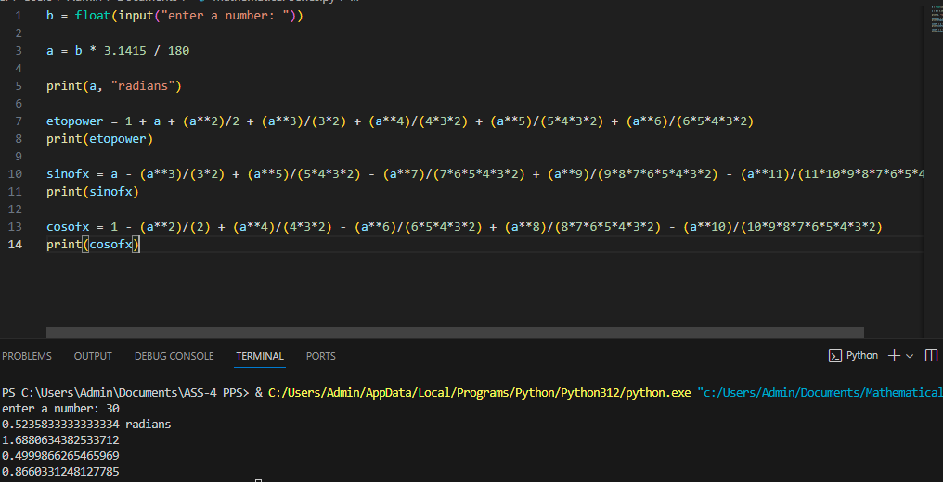

**Q.7)** Write a program to find whether a given number is Armstrong number or not.

abcd... = pow(a,n) + pow(b,n) + pow(c,n) + pow(d,n) + ....

EX: 153 = 1*1*1 + 5*5*5 + 3*3*3 // 153 is an Armstrong number.

**ANS:**

num= int(input("Enter the number: "))  
str_num=str(num)  
sum=0  
for digit in str_num:  
 digit=int(digit)  
 sum+=(digit**3)  
if sum== num:  
 print("Armstrong")  
else:  
 print("Not Armstrong")

**Q.8)Write a program to print the follwong pyramid patterns using loops:**

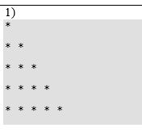

**ANS:**

for i in range(1,6):

print()

for j in range(1,i+1):

print("*",end="")

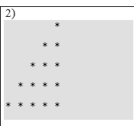

**ANS:**

n=int(input("enter the number of rows:"))

for i in range(n):

for j in range(n-i-1):

print(" ",end="")

for j in range(i+1):

print("*",end="")

print()

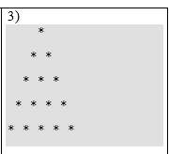

**ANS:**

num_rows = int(input("Enter the number of rows:"));

for i in range(0, num_rows):

for j in range(0, num_rows-i-1):

print(end=" ")

for j in range(0, i+1):

print("*", end=" ")

print()

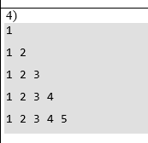

**ANS:**

for i in range(1,6):

print()

for j in range(1,i+1):

print(j,end=" ")

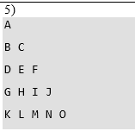

**ANS:**

n=5

num=65

for i in range(0,n):

for j in range(0,i+1):

ch=chr(num)

print(ch,end="")

num=num+1

print()

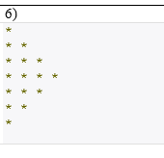

**ANS:**

print("Program to print star pattern: \n");

rows = input("Enter maximum stars you want display on a single line")

rows = int (rows)

for i in range (0, rows):

for j in range(0, i + 1):

print("* ", end='')

print("\r")

for i in range (rows, 0, -1):

for j in range(0, i -1):

print("* ", end='')

print("\r")